**ORAL EXAM**

**CARDS**

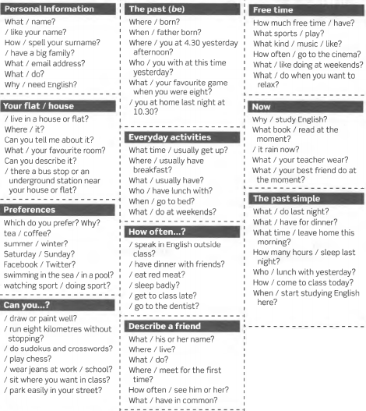

**SITUATIONS**

**AT A CLOTHES SHOP**

You are a customer. Student A is a shop assistant and starts the conversation. You:

* Ask if the shop has any trousers.
* Ask how much the trousers are.
* Pay.
* Say thank you and goodbye.

**AT A CLOTHES SHOP**

You are a shop assistant. Student B is your customer. Create a conversation in which you:

* Say hello and offer to help.
* Say where the trousers are.
* The trousers are £24.99.
* Ask if that is everything.

**ARRANGING A MEETING**

Student A calls you to go for a coffee. Accept his offer and ask her/him the place and time of the meeting. Ask her/him how to get to the place.

**ARRANGING A MEETING**

You are Student A and you call Student B to go for a coffee. Tell her/him where and when you can have the coffee. Explain her/him how to get to the place and the bus that takes her/him there.

**ROOMS AND FURNITURE**

Your best friend and you plan to go on holidays to Chile very soon. She/ He calls to tell you about a flat you can rent. Make questions about the following aspects:

* Where the flat is located
* Rooms: quantity, space
* Facilities
* Price

Finish the conversation telling your friend your personal opinion about the flat.

**BUYING COFFEE**

You plan to go on holidays to Chile very soon with your best friend. Call your friend and tell her/him about a flat you want to rent. Be ready to answer your friend’s questions with the following information:

* Flat near the sea
* 2 small rooms, 1 bathroom and a kitchen
* Air conditioning but no TV
* Price: $20 per day

**AT THE HOTEL**

You arrive in London and go to the first hotel you can find in the city. Speak to the receptionist and ask her/him for a room. Also, give the following information to fill in a registration card:

* Full name
* Nationality
* Address
* Telephone number
* Nights in the hotel
* Payment: with cash

**AT THE HOTEL**

You are the receptionist of a hotel. A visitor comes to ask for a room. Explain that you have a single room available and ask her/him the following information to fill in a registration card:

* Full name
* Nationality
* Address
* Telephone number
* Nights in the hotel
* Payment: with cash or credit card

**BUYING COFFEE**

Person A is the client and person B the waiter/waitress.

Take part in a conversation buying something to eat and something to drink.

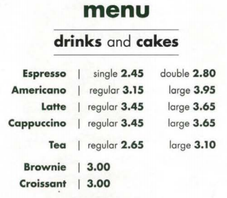

**GOING SIGHTSEEING**

Person A is at a hotel and he/she asks for directions a building (eg. the bank). Start with “Excuse me, where is ... ?

Person B gives directions.

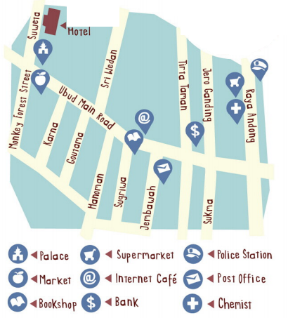

**A MEMORABLE NIGHT N IN YOUR LIFE**

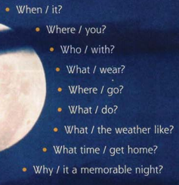

|  |  |  |  |  |
| --- | --- | --- | --- | --- |
| **Name:** | | | **Date:** | |
|  | Content  (20 marks) | Structure – Organization  (30 marks) | Vocabulary  (30 marks) | Pronunciation  (20 marks) |
| PART 1  (3 cards: one for Present Simple, one for Present Continuous and 1 for Simple Past) |  |  |  |  |
| PART 2  (1 situation) |  |  |  |  |
| Final Score: |  |  |  |  |